Q:

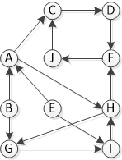

Run **DFS** on the given graph and show all the steps (**discovery and finish times, predecessor/parent**).  
  
You have to start from **F**, keep in mind the application of DFS should be in **alphabetical order**